**Steps to run our software:**

1. Open CryptoPP/AES CBC IV=0
2. Now your folder looks like this: 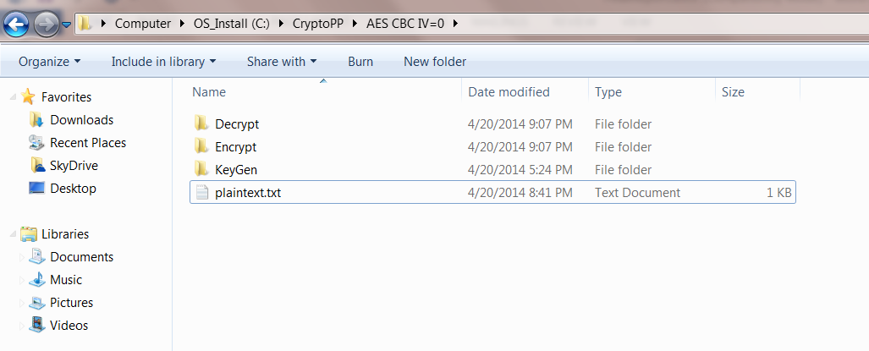
3. Open KeyGen/Debug and run KeyGen.exe. You will find 3 files being generated as follows: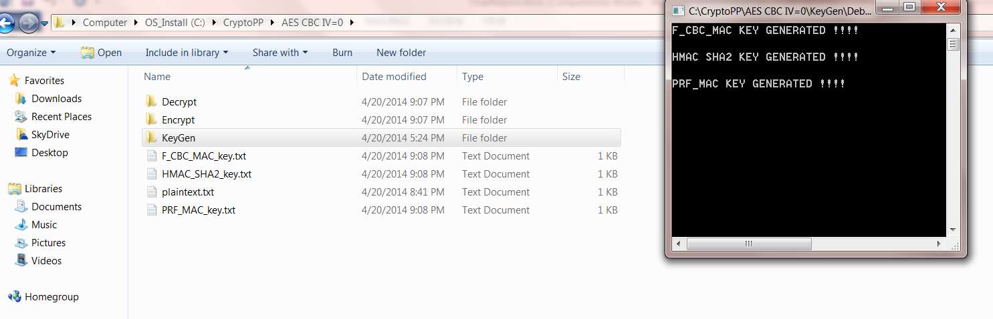
4. Now, open Encrypt/Debug and run Encrypt.exe to generate cipher text files.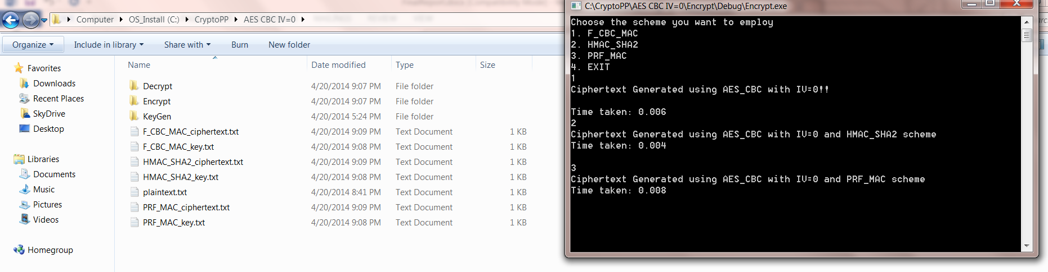
5. Lastly, open Decrypt/Debug and run Decrypt.exe to generate decrypted text files.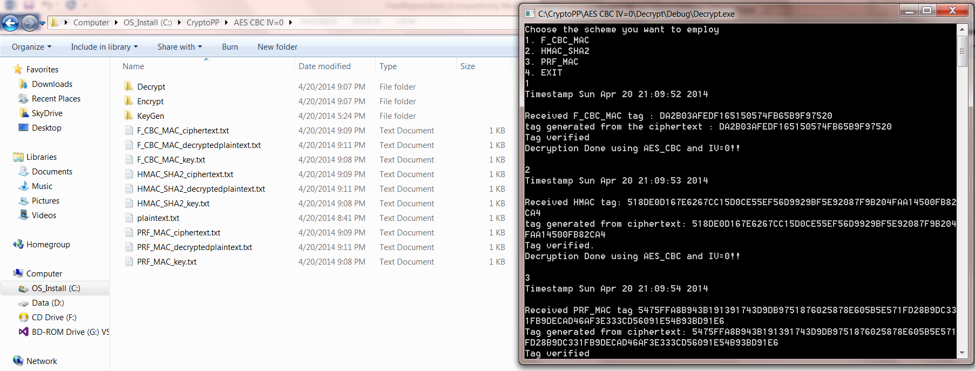
6. Similarly, do for other encryption scheme.

Please note: you can change the data inside the plaintext.txt as per your requirement.